Welcome to the fourth segment of Getting Started with Google Suite. By the end of this segment, you should be able to explain how to access Google Slides, be able to demonstrate the basics of how to use Google Slides, be able to explain the two main ways to work with Google Slides offline, and be able to demonstrate how to convert a Microsoft PowerPoint into a Google Slide presentation.

**How to access Google Slides?**

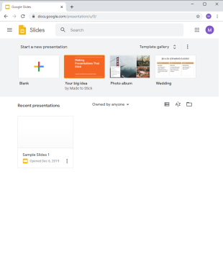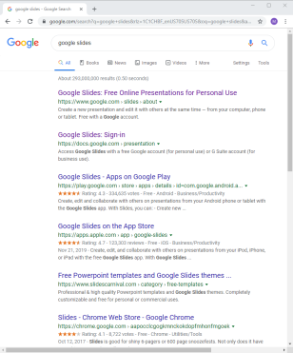There are two ways to access Google Slides depending on what you are looking to do. The first is to go to Google Slides. To do this: Open Chrome, click in the address bar at the top and type in “Google Slides” and then hit enter. In the search results that come up click on the second link that says “Google Slides”. Using this route will allow you to easily access the template gallery and see what the templates look like without taking an extra step. The downside is that it will auto-create the file in your main Google Drive, which can cause file chaos if you do not take time to organize it.

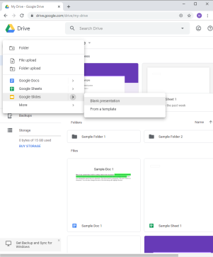The second way to access Google Slides is to go through Google Drive. To do this: Open Chrome, click in the address bar at the top and type in “Google Drive” and hit enter. Click on the “Google Drive” that pops up in the search results and it will take you to your Drive. Then click on the “New” button up in the top left corner, go down to Google Slides, hover over the right pointing arrow and either choose “Blank Document” or “From a Template”. Using this route will allow you to create in the folder where you want it to be, in turn keeping things organized. It also allows you to access the template gallery but does take an extra step with being able to view and choose the one you want to use.

**How to get started with Google Slides**

For those that have used Microsoft PowerPoint using Google Slides will be very similar with just a few formatting options located in different places. Becoming proficient in Google Slides will be just like becoming proficient in Microsoft PowerPoint right after they release a new edition where they moved all the buttons. For those that are not familiar with Microsoft PowerPoint then, good news, Google Slides is easy to learn the basics.

By the end of this section you should know how to be able to effect the overall slide formatting (changing the theme or background), rename the file, edit and effect the text, add slides and change their layouts, insert images, video, audio, and textboxes, and how to present the presentation.

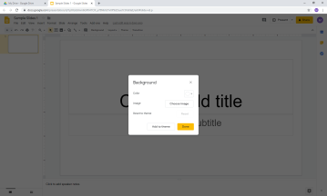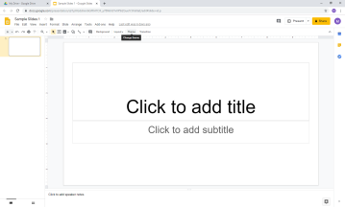Once you have opened a new Google Slides presentation you have a couple of options of where to start. I would suggest starting with the overall formatting of the presentation which means determining either the theme or the background for the presentation. If you would like to use a preset theme and it has not popped up on the right hand side when you opened it, then you will click the “Theme” button up on the top which will cause a window to open on the right showing you which themes are available. If you would like to just apply a background because you want to pick your text colors then click on “Background”, which will open a pop up box allowing you to choose a color or an image to set for the background. Be careful with setting images as backgrounds as it can make reading text on the slides difficult without some extra steps.

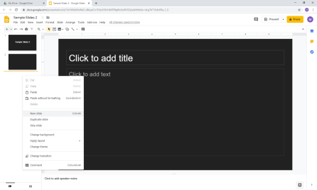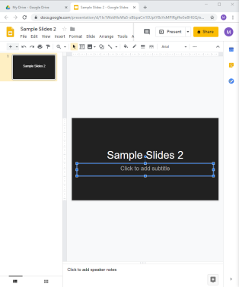Now that you have set up the layout of your slides it’s time to put the title of the presentation in. Do this by clicking where it says “Click to add title”. Once you are done with that I would suggest clicking up in the top left-hand corner where it says “Untitled presentation” and as with all of the Google creative apps it will take the first couple of words and make it the file name. If you would like to remove the box underneath your title that says “Click to add subtitle” click on the box outline, which will cause it to highlight blue and then press delete. If you would like to change the texts font, size, color, or alignment the options to do so are up in the top, but they will disappear if you do not have any text or text object selected so make sure that you have selected your text. 

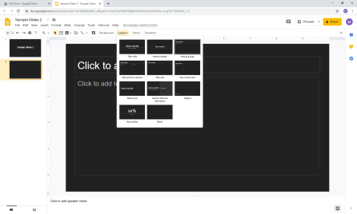Very few slide presentations are only one slide so let’s cover how to add a new slide next. Click over on the left-hand side under where slide 1 is. Then either right-click and select new slide or click on “Insert” and then select new slide. I generally find it easier to right click. If you would like to change the layout of the side to something other than a title and text box then click on “Layout” up at the top which will open a dropdown menu and select the type you would like. I generally find it easier to work with blank slides.

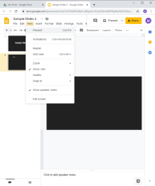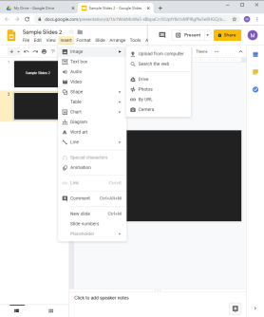Next up is inserting images, video, audio, and textboxes. As I mentioned I prefer to work with blank slides this is because it allows me to format the slide how I want to, but to do so it’s important to understand how to insert the elements. Doing so is very simple. When it comes to inserting images you have three options. If you are working with an image that you have found online then you can simply copy and paste it into Google Slides, remember somethings may be copyright. Your other two options are to either: click on “Insert,” hover your mouse over “Image,” and then select the correct option of what you would like or you can click on the little image of mountains in the tool bar which will open the same option menu. The only way to insert video and audio is to go through the “Insert” menu. Inserting textboxes is just like the images you can either go through the “Insert” menu or you can click on the T inside of a box on the toolbar. No matter which option you choose when you take your mouse down to the slide you will notice that has become a big plus. You can either click and drag to place the size of box that you would like or just simply click and it will auto-generate a box. WARNING if you do not type anything after you place a text box it will disappear and you will need to place a new one.

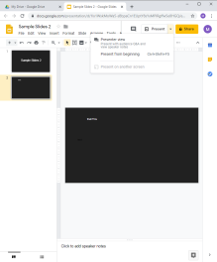Last thing to cover before you are proficient with basics is how to present the presentation. There are two options for this: you can click on the “Present” button up in the top right-hand corner or you could also click on “View” and then click on “Present”. You might be wondering “what is the difference between the two ways?” and really there is none. Clicking on the little down arrow next to the present in the top right-hand corner will give you an option to start the presentation from the beginning if you are not on slide one, where both of the other present buttons starts the presentation on whichever slide you have selected

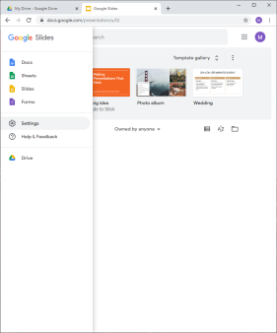**How to Work with Google Slides Off-line**

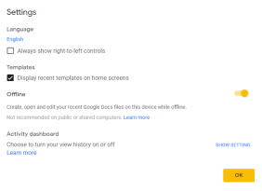If you ever need to work off-line yet the file you need to work with is a Google Slide don’t worry you have a couple of options. One option, which if you are staying on the same computer would probably be the best, is to turn on off-line mode. To do this: Open Chrome, click in the address bar at the top and type in “Google Slides” and hit enter. In the search results that come up click on the second link “Google Slides”. Then in the top left-hand corner click on the triple-stacked lines, click “Settings” and make sure that the slider next to Offline is yellow. WARNING this only works with your recent Google Slide files so you need to make sure that you have opened what you want to work with within a day or two of when you are planning on going offline.

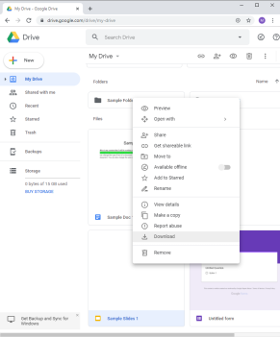

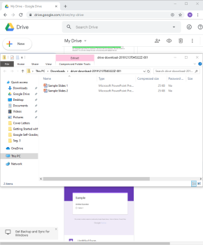 The second option would be to download any Google Slides that you want to work with as a PowerPoint Document, edit as needed and then when you have internet back upload them and convert them back to Google Slides. There are two ways to do this. If you are just planning on working with a single file then go to your Google Drive, locate the file, right-click on the file and select download. Once the file downloads, it will show up in the bottom left-hand corner of your screen. Go ahead and open the file and save it to a location where you will be able to find it again. Suggestions would be either the “Desktop” or “My Document.”

If you are planning on downloading multiples files then the easiest way would be to select all of the files either by selecting the first file pressing and holding the shift key and then selecting the last file if they are in order or by selecting the first file, pressing the control key and then selecting the next file if they are not in order. Once the files are selected release the shift or control key, right-click, and click on “download.” A little box will pop up in the bottom right-hand corner to show you the progress, and then once the files have been downloaded a folder will pop up in the bottom left-hand corner. You are going to want to click on it then select all of the files you have downloaded and drag them to a location where you will be able to find them again. Suggestions would be either the “Desktop” or “My Document.”

**Advanced Slide Creation**

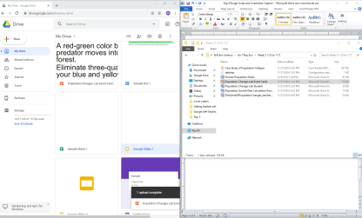 If you already have Microsoft PowerPoint presentations and want to or need to convert them to Google Slide presentations you can do so. You will need to upload your Microsoft PowerPoint to your Google Drive by clicking it and dragging it and then opening it; up at the top there will be an option to “Open with Google Slides” clicking this will automatically turn it into a Google Slides presentation. It may take a few moments. Be sure to check the formatting of your presentation as things can get a little messy during conversion. Due to a new update instead of automatically converting your Microsoft PowerPoint presentation into a Google Slide presentation Google now allows you to edit the PowerPoint in Slides and saves the changes to the PowerPoint automatically. If you would like to save the presentation as a Google Slides then you will need to click on “File” “Save as Google Slides”. Checking your google Drive will show you that you now have a PowerPoint and a Slides of the same file.

This concludes this segment of Getting Started with Google Suite. By now you should be able to explain how to access Google Slides, be able to demonstrate the basics of how to use Google Slides, be able to explain the two main ways to work with Google Slides offline, and be able to demonstrate how to convert a Microsoft PowerPoint into a Google Slide presentation.

The next segment will be about Google Sheets.